A MINI PROJECT REPORT
On
HR Case Study:
Matching HRs with right Interns

Submitted by

Name: Anujay Jain Name: Nihit Jain
Roll No: 161500106 Roll No: 161500350

Name: Utkarsh Rai Name: Shahaban Ali
Roll No: 161500599 Roll No:161500496

To
Mr. Rahul Pradhan

Department of Computer Engineering & Applications
Institute of Engineering & Technology



GLA University
Mathura- 281406, INDIA
December, 2018
Department of Computer Engineering and Applications
GLA University, Mathura
17 km. Stone NH#2, Mathura-Delhi Road, P.O. – Chaumuha,
Mathura – 281406

Declaration
We hereby declare that the work which is being presented in the Mini Project “Multiple Regression and Model Building”, in partial fulfillment of the requirements for Mini-Project LAB, is an authentic record of our own work carried under the supervision of Mr. Rahul Pradhan, Assistant Professor, GLA University, Mathura.

Anujay Jain
Sign:_________

Nihit Jain
Sign:_________

Utkarsh Rai
Sign:_________

Shahaban Ali

Sign:_________

Department of Computer Engineering and Applications
GLA University, Mathura
17 km. Stone NH#2, Mathura-Delhi Road, P.O. – Chaumuha,
Mathura – 281406

CERTIFICATE

This is to certify that the project entitled “HR Case Study: Matching HRs with right Interns” carried out in Mini Project – I Lab is a bonafide work done by Anujay Jain (161500106), Nihit Jain (161500350), Shahaban Ali(161500599) and Utkarsh Rai (161500599)and is submitted in partial fulfillment of the requirements for the award of the degree Bachelor of Technology (Computer Science & Engineering).

Signature of Supervisor:

Name of Supervisor:

Date:

ACKNOWLEDGEMENT

It gives us a great sense of pleasure to present the report of the B. Tech Mini Project undertaken during B. Tech. Third Year. This project in itself is an acknowledgement to the inspiration, drive and technical assistance contributed to it by many individuals. This project would never have seen the light of the day without the help and guidance that we have received.

Our heartiest thanks to Dr. (Prof). Anand Singh Jalal, Head of Dept., Department of CEA for providing us with an encouraging platform to develop this project, which thus helped us in shaping our abilities towards a constructive goal.

We owe special debt of gratitude to Mr. Rahul Pradhan, Assistant Professor Department of CEA, for his constant support and guidance throughout the course of our work. His sincerity, thoroughness and perseverance have been a constant source of inspiration for us. He has showered us with all his extensively experienced ideas and insightful comments at virtually all stages of the project & has also taught us about the latest industry-oriented technologies.

We also do not like to miss the opportunity to acknowledge the contribution of all faculty members of the department for their kind guidance and cooperation during the development of our project. Last but not the least, we acknowledge our friends for their contribution in the completion of the project.

Anujay Jain
Nihit Jain
Utkarsh Rai
Shahaban Ali

Abstract
In this problem, we have been provided with the information about various internships posted on Internshala. This includes various attributes about the internships like location, duration, start_date of internship etc. We have also been provided with information about the students who have applied for the internship. These include type_of_institute, current_year, academic performance of the student etc. Any student is free to apply for any internship on the portal.

While employers get high response to their posting, it is difficult to go through a high number of applications for the employers. They might need to go through high number of applications to shortlist the most relevant candidates. Hence an intelligent matching algorithm can help our users get better experience and enhance chances of meaningful profile matches.

Table of Contents
Declaration ii
Certificate iii
Acknowledgments iv
Abstract v

Table of Contents vi

- Chapter 1 1
1.1 Business Understanding….……………………...................................................1
1.2 Motivation .…………………………………………………...............................1
1.3 Scope…………………………………………………………………………….1
1.4 Drawbacks in existing system…………………………………………………...1

- Chapter 2 2
2.1 General Description…………………………………………………… ………..2
2.2 Project plan.……….……………..….………………………………………...…2
2.2.1 Objective…………………………………………………………………...2
2.2.2 Goal………………………………………………………………………...2
3. Chapter 3 3
3.1 Project Implementation……………………………………………………………3
3.2 Understanding the dataset………………………………………………………....3
3.3 Describe Data……………………………………………………………………...5
3.4 Data cleaning………………………………………………………………………6
3.5 Model used…………………………………………………………………………7
3.6 Data insights……………………………………………………………………….7

4. Chapter 4 12
4.1 Appendices……..……………………….…………………………………………12

CHAPTER 1

1.1 Business Understanding
While employers get high response to their posting, it is difficult to go through a high number of applications for the employers. They might need to go through high number of applications to shortlist the most relevant candidates. Hence an intelligent matching algorithm can help our users get better experience and enhance chances of meaningful profile matches.

1.2 Motivation
The main motivation for us to go for this project was that a lot of internships are provided on internshala and a lot of applications for these internship are there, now if it the selection of the application is done manually it will consume lots of time and man-power and there are chances of human error. It is not possible to reduce the error of selection completely but if we can design a programme to select the most suitable candidate for a given internship then we ca reduce the time consumed and the workload and as it is being done by a machine the chances of error will also will be reduced and that is our goal.

1.3 Scope

The scope of our analysis is that we can reduce the workload for the company while selecting the most suitable interns for them among all the applicants. This is so, as based on our analysis we can find out those attributes which are most significant for the selection of the applicants thus helping us to focus on only those attributes rather than wasting our effort and time on other unrelated areas. Thus it will help as follows:
- Reduce the workload.
- Reduce the time consumed while selecting the suitable candidates.
- It can also be used by the applicants to know which are the more suitable internship for them.

1.4 Drawbacks in existing system

  - These days the selection for the internship is done manually which consumes more time.

  - These days the number of domains for which you can apply is increasing and the criteria for applying for an intern as well as the specification which the applicants are searching for has increased a lot thus increasing the chance of error while selecting the most suitable applicants.

CHAPTER 2

  - General Description
- Data collected from Internshala.
- A data is recorded in a file - Internship.csv, Student.csv and train.csv
2.2 Project Plan
2.2.1 Objective
- Build the best multiple regression model that can predict the most suitable candidate for the various internship present on the internshala, using all the other variables as the predictors.
- Determine which variables must be made into indicator variables.
- Determine which variables might be superfluous.

2.2.2 Goals
- To reduce the total number of applicants a company has to go over during the selection for the internship.
- To reduce the chances of error of selection a less suitable applicant when a more suitable one is present.

CHAPTER 3
3.1 Project Implementation
It includes the steps taken to implement the project.

3.2 Understanding the Dataset

- Student.csv
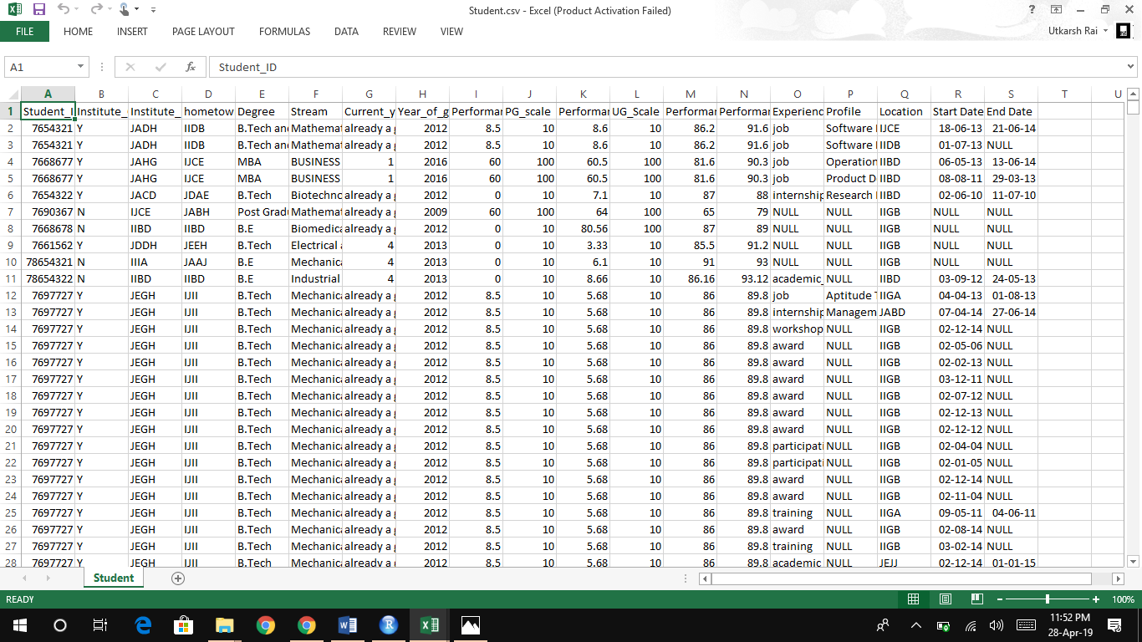

- Internship.csv

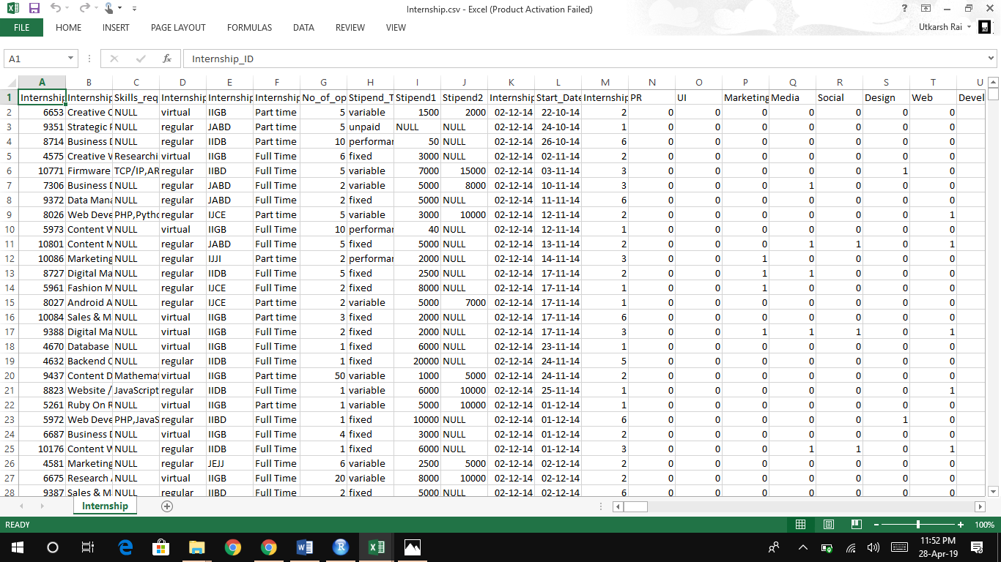

- train.csv
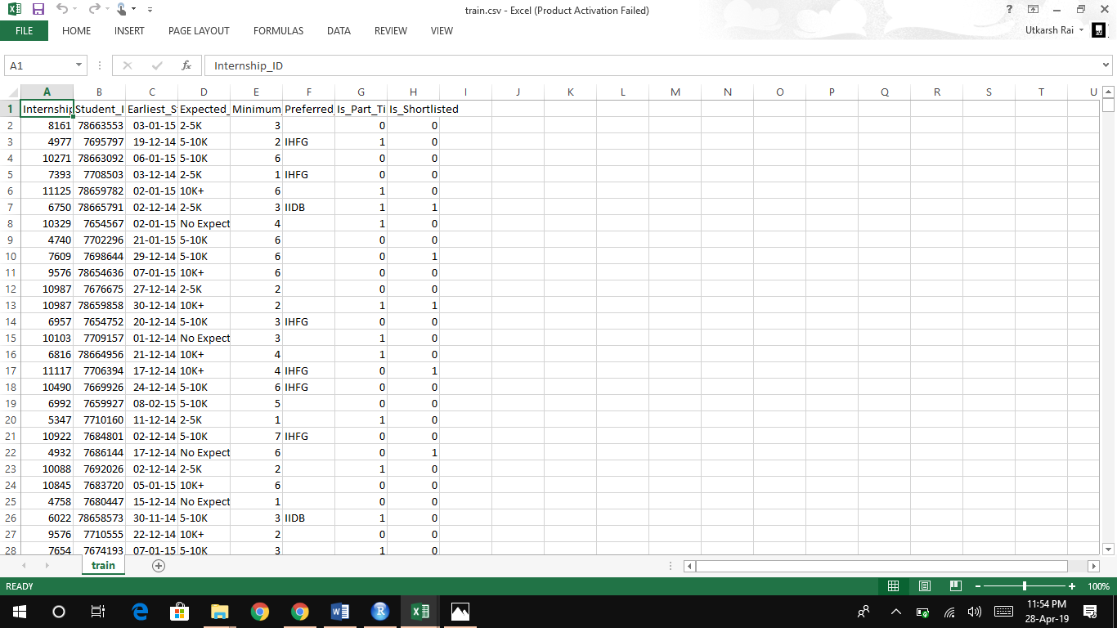

3.3 Describe data
The description of the column is as follows:

- Student.csv → It has 19 columns and 151191 rows.

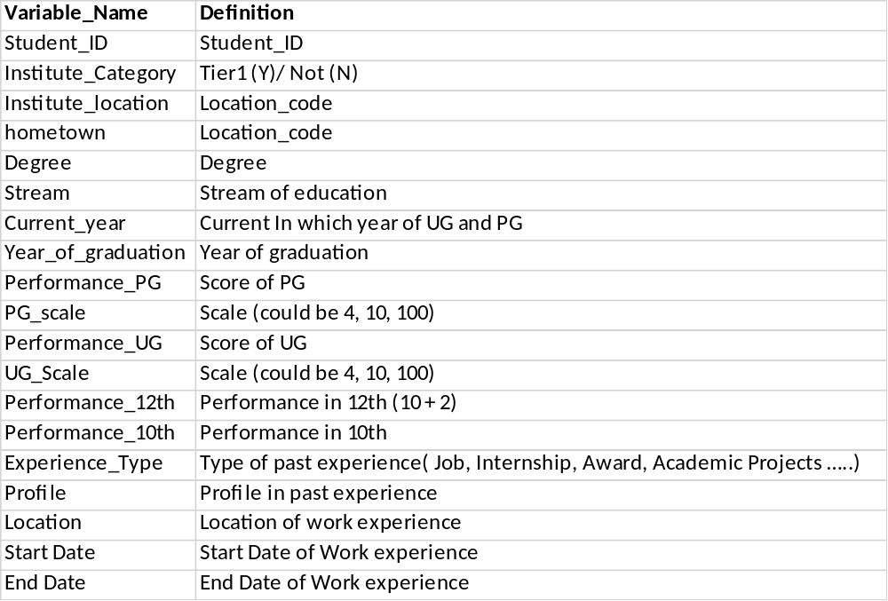

- Internship.csv → It has 286 columns and 6899 rows.

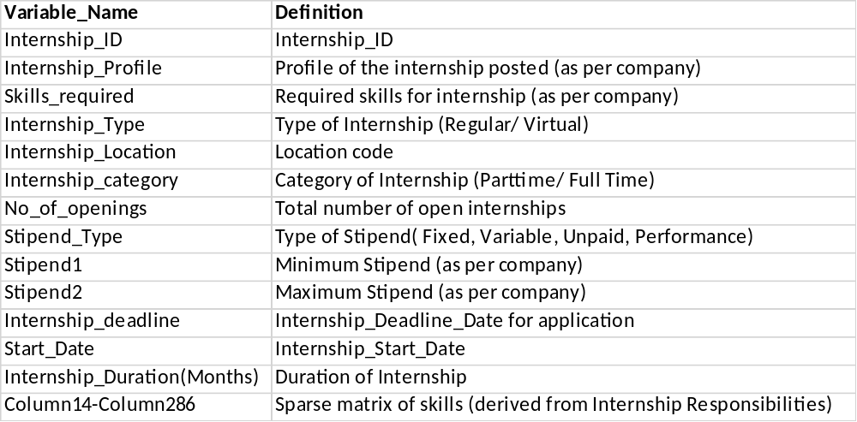

- train.csv → It has 8 columns and 192582 rows.

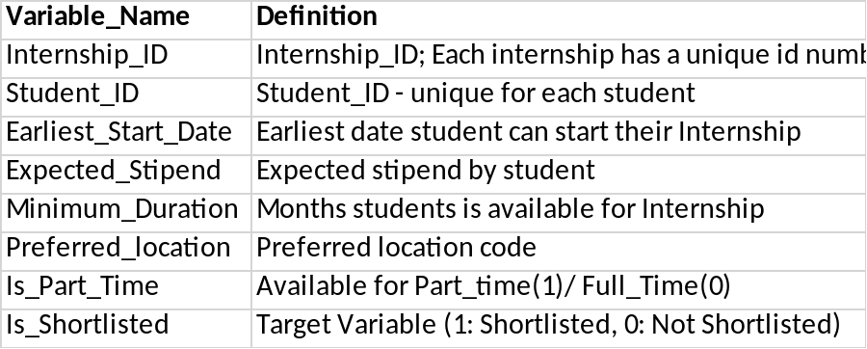

3.4 Data cleaning
The data which is obtained may need to be processed before it can be actually used, like there may be some values missing which need to be filled otherwise they will cause problem when doing the analyses on the data.

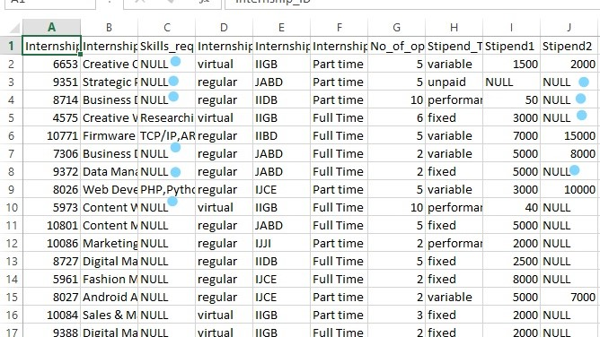

In the above image we can see that there are some null values so we need to fill them before we do anything else.

3.5 Model used
Since our problem is a classification problem and has a very large size of more than 100k samples , we decided to use the technique of Gradient descent for which the most suitable algorithm is Gradient boosting which is able to solve the problem of large size , handling data of mixed type and missing values, robust to outliers in input space and has a good interpretability and predictive power.

Gradient descent is an optimization algorithm used to minimize some function by iteratively moving in the direction of steepest descent as defined by the negative of the gradient. In machine learning, we use gradient descent to update the parameters of our model.
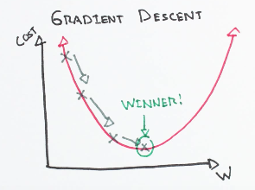

Gradient boosting is a machine learning technique for regression and classification problems, which produces a prediction model in the form of an ensemble of weak prediction models, typically decision trees.

3.6 Data Insights

Here are certain insights of the data which may help in analyses

- A general view of the datasets.
train.csv
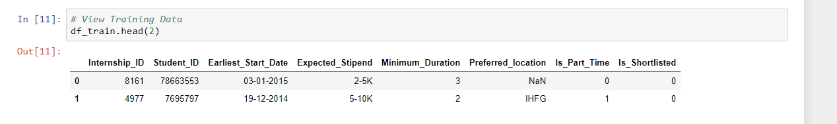

Internship.csv
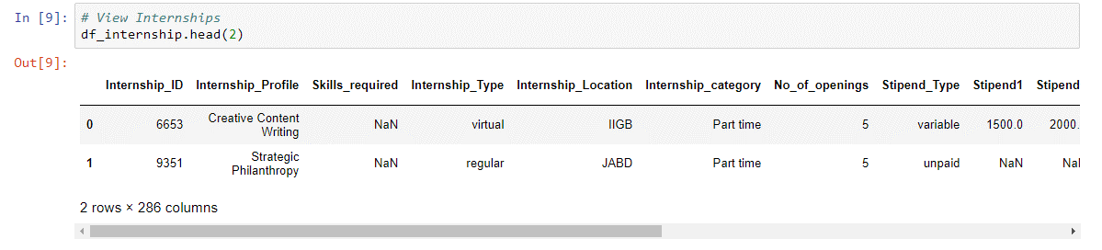
Student.csv
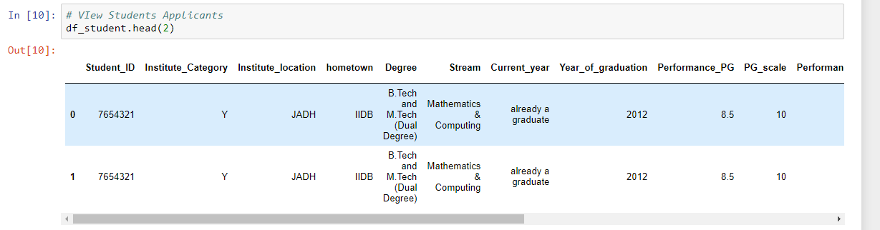

- Summary of the datasets before preprocessing

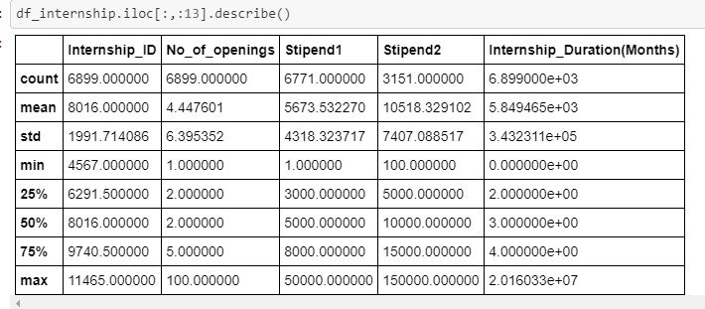

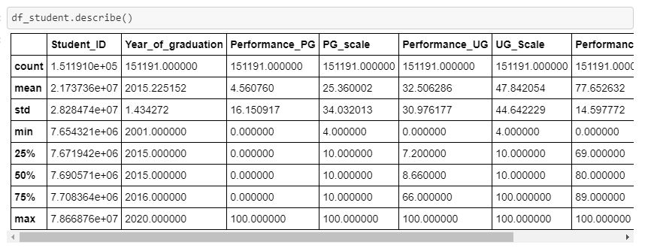
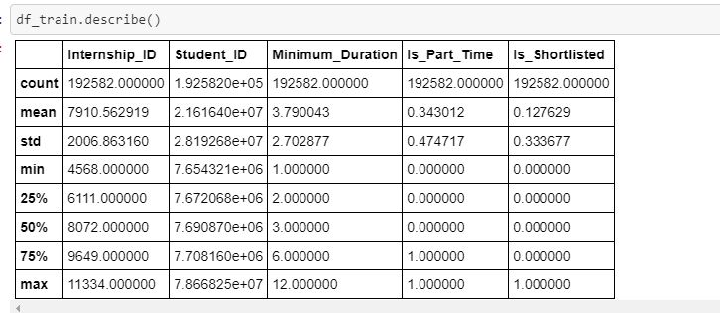

- Model fitting
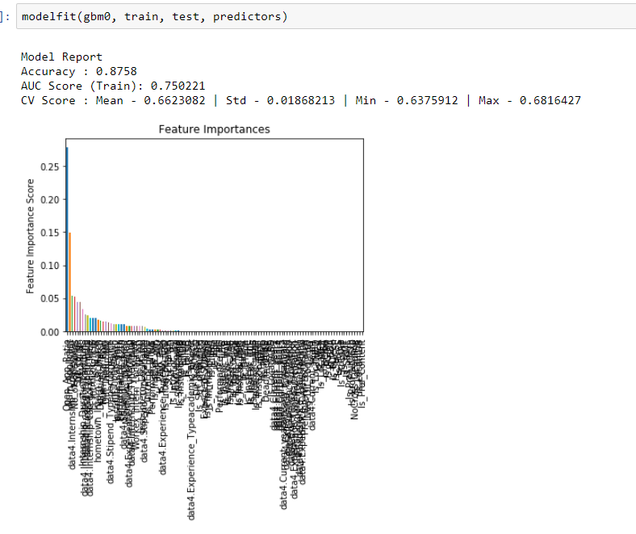
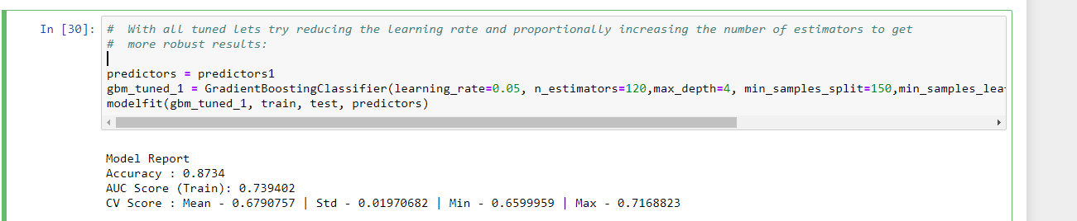

- Improvement in the model
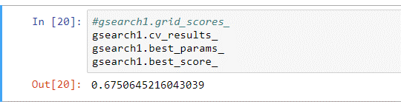
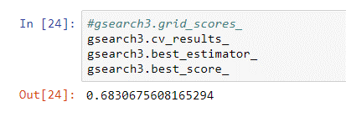

Chapter 7

Appendices

Code:

Data Cleaning

interns <- read.csv("trainfiles/Internship/Internship.csv")
student <- read.csv("trainfiles/Student/Student.csv")
train <- read.csv("trainfiles/traincsv/train.csv")
test <- read.csv("test-date-your-data/test.csv")

#install.packages("sqldf")

library(sqldf)
student1 <- student
student1$S_Date <- student1$Start.Date
student1$E_Date <- student1$End.Date
student1$Num_Exp <- 1
student2 <- sqldf("select Student_ID, Institute_Category, Institute_location ,hometown ,Degree,
Stream, Current_year, Year_of_graduation, Performance_PG, PG_scale,
Performance_UG, UG_Scale, Performance_12th, Performance_10th, Experience_Type,
Profile, Location, S_Date, E_Date, SUM(Num_Exp) as Num_Exp_Row From student1 Group BY Student_ID")

# Converting S_Date, E_Date to date class
S_Date <- as.Date(student2$S_Date, "%d-%m-%Y")
E_Date <- as.Date(student2$E_Date, "%d-%m-%Y")

student2$S_Date <- S_Date
student2$E_Date <- E_Date

# tagging train and test data
train1 <- train
train1$tag <- "train"
test1 <- test
test1$tag <- "test"

#Combining train and test
test1$Is_Shortlisted <- 0
data <- rbind(train1,test1)

#combining data and student2

data1 <- merge(data,student2,by="Student_ID",all.x=TRUE)
interns1 <- interns[,c(1:13)]
data2 <- merge(data1,interns1, by="Internship_ID", all.x=TRUE)

## modification of Earliest_Start_Date

ESD <- data2$Earliest_Start_Date
ESD1 <- gsub('/','-',ESD)
ESD2 <- as.Date(ESD1, "%d-%m-%Y")
data2$Earliest_Start_Date <- ESD2

## Converting "Start_Date" to Date class
Start_Date <- data2$Start_Date
Start_Date <- as.Date(Start_Date,"%d-%m-%Y")
data2$Start_Date <- Start_Date

## Class balance
table(train$Is_Shortlisted)
# 0 1
#168003 24579

## Converting to factor variables Degree ,Stream , Profile
data2$Degree <- as.factor(data2$Degree)
data2$Stream <- as.factor(data2$Stream)
data2$Profile <-as.factor(data2$Profile)
data3 <- data2

# missing value treatment of data3$Preferred_location
# Lets tag it as No_Pref and create a feature to tag it
data3$Preferred_location <- as.character(data3$Preferred_location)
data3$Preferred_location <- ifelse(data3$Preferred_location=="","No_Pref",data3$Preferred_location)
data3$Preferred_location <- as.factor(data3$Preferred_location)

# substituting NA values of Degree with most common category
data3$Degree <- as.character(data3$Degree)
data3$Degree <- ifelse(is.na(data3$Degree) & data3$Stream=="Management", "MBA",data3$Degree)
data3$Degree <- ifelse(is.na(data3$Degree) & data3$Stream=="Fashion Lifestyle Business Management", "MBA",data3$Degree)
data3$Degree <- ifelse(is.na(data3$Degree) & data3$Stream=="Commence", "B.Com",data3$Degree)
data3$Degree <- ifelse(is.na(data3$Degree) & data3$Stream=="Commerce", "B.Com",data3$Degree)

data3$Degree <- ifelse(is.na(data3$Degree) & data3$Internship_Profile=="Design", "Designing",data3$Degree)
data3$Degree <- ifelse(is.na(data3$Degree) & data3$Internship_Profile=="Social Media Marketing", "Digital Marketing",data3$Degree)
data3$Degree <- ifelse(is.na(data3$Degree) & data3$Internship_Profile=="Graphic Design", "Graphic Design",data3$Degree)
data3$Degree <- ifelse(is.na(data3$Degree) & data3$Internship_Profile=="Digital Marketing", "Digital Marketing",data3$Degree)
data3$Degree <- ifelse(is.na(data3$Degree) & data3$Internship_Profile=="Illustration", "B.A.(Hons) Journalism",data3$Degree)
data3$Degree <- ifelse(is.na(data3$Degree) & data3$Internship_Profile=="Google Ad Word Management", "MBA",data3$Degree)
data3$Degree <- ifelse(is.na(data3$Degree) & data3$Internship_Profile=="Operations- Quality Analyst", "Global Business Operations (GBO)",data3$Degree)

data3$Degree <- as.factor(data3$Degree)

# substituting NA values of Stream
data3$Stream <- as.character(data3$Stream)
data3$Stream <- ifelse(is.na(data3$Stream) & data3$Degree=="Designing", "Accessory Designing",data3$Stream)
data3$Stream <- ifelse(is.na(data3$Stream) & data3$Degree=="MCA", "Computer Application",data3$Stream)
data3$Stream <- ifelse(is.na(data3$Stream) & data3$Degree=="Post Graduate Dimploma in Management", "Marketing",data3$Stream)
data3$Stream <- ifelse(is.na(data3$Stream) & data3$Degree=="MBA", "Marketing",data3$Stream)
data3$Stream <- ifelse(is.na(data3$Stream) & data3$Degree=="B.Com (Hons.)", "Accountancy And Finance",data3$Stream)
data3$Stream <- ifelse(is.na(data3$Stream) & data3$Degree=="Graphic Design", "Visual Comm",data3$Stream)
data3$Stream <- ifelse(is.na(data3$Stream) & data3$Degree=="Bachelor of Business Admininstration", "Management",data3$Stream)
data3$Stream <- ifelse(is.na(data3$Stream) & data3$Degree=="Digital Marketing", "Commerce",data3$Stream)
data3$Stream <- ifelse(is.na(data3$Stream) & data3$Degree=="B.M.M.", "Arts",data3$Stream)
data3$Stream <- ifelse(is.na(data3$Stream) & data3$Degree=="BCA", "Computer Application",data3$Stream)
data3$Stream <- ifelse(is.na(data3$Stream) & data3$Degree=="Global Business Operations (GBO)", "Finance",data3$Stream)
data3$Stream <- ifelse(is.na(data3$Stream) & data3$Degree=="B.A.LL.B. (Hons.)", "Law",data3$Stream)
data3$Stream <- ifelse(is.na(data3$Stream) & data3$Degree=="Under", "Under",data3$Stream)
data3$Stream <- ifelse(is.na(data3$Stream) & data3$Degree=="B.A. Programme", "Arts",data3$Stream)
data3$Stream <- ifelse(is.na(data3$Stream) & data3$Degree=="B.Sc (Hons.) Computer Science", "Science",data3$Stream)
data3$Stream <- ifelse(is.na(data3$Stream) & data3$Degree=="B.S. & M.S. (Dual)", "Mathematics and Computing",data3$Stream)
data3$Stream <- ifelse(is.na(data3$Stream) & data3$Degree=="Undecided", "Undecided",data3$Stream)
data3$Stream <- ifelse(is.na(data3$Stream) & data3$Degree=="B.A.(Hons) Journalism", "Arts",data3$Stream)
data3$Stream <- ifelse(is.na(data3$Stream) & data3$Internship_Profile=="Editorial(Law)", "Law",data3$Stream)
data3$Stream <- as.factor(data3$Stream)

# Replacing NULL in Experience_Type , Profile with No_Exp
summary(data3$Experience_Type)
summary(data3$Profile)
data3$Profile <- as.character(data3$Profile)
data3$Experience_Type <- as.character(data3$Experience_Type)

table(as.factor(data3$Experience_Type))
data3$Profile[data3$Experience_Type!="NULL" & data3$Profile=="NULL"]<- "Intern"
data3$Profile[is.na(data3$Profile)] <- "Intern"

data3$Experience_Type[data3$Experience_Type=="NULL"] <- "No_Exp"
data3$Profile[data3$Profile=="NULL"] <- "No_Exp"

table(data3$Experience_Type)
sort(table(as.factor(data3$Profile)),decreasing=TRUE)[1:50]

data3$Profile <- as.factor(data3$Profile)
data3$Experience_Type <- as.factor(data3$Experience_Type)

# NAs in S_Date , E_Date

data3$S_Date <- as.character(data3$S_Date)
data3$E_Date <- as.character(data3$E_Date)

data3$S_Date[is.na(data3$S_Date) & data3$Experience_Type=="No_Exp"] <- "2015-02-21"
data3$E_Date[is.na(data3$E_Date) & data3$Experience_Type=="No_Exp"] <- "2015-02-21"
data3$S_Date <- as.Date(data3$S_Date,"%Y-%m-%d")
data3$E_Date <- as.Date(data3$E_Date,"%Y-%m-%d")

data3$E_Date[is.na(data3$E_Date)] <- as.Date("21-02-2015", "%d-%m-%Y")
max(data3$E_Date)

#NULL values of Stipend1 (2859 NULL values)
data3$Stipend1 <- as.character(data3$Stipend1)
data3$Stipend1 <- as.numeric(data3$Stipend1)
sum(is.na(data3$Stipend1))
sum(is.na(data3$Stipend1[data3$Stipend_Type=="unpaid"]))

## Stipend_Type == "unpaid" are NA or NULL in Stipend1; can replace them as 0
data3$Stipend1 <- ifelse(is.na(data3$Stipend1),0,data3$Stipend1)
table(data3$Stipend1[data3$Stipend_Type=="unpaid"])
# (7+5) obs in data3$Stipend1 has values otherthan 0 when Stipend_Type=="unpaid"
# Converting them to 0
#data3$Stipend1 <- ifelse(data3$Stipend_Type=="unpaid",0,data3$Stipend1)
data3$Stipend1 <- as.numeric(as.character(data3$Stipend1))
data3$Stipend1[data3$Stipend_Type=="unpaid"] <- 0

#NULL values of stipend2 (151897 NULL values) replaced by median
data3$Stipend2 <- as.numeric(as.character(data3$Stipend2))
data3$Stipend2[data3$Stipend_Type=="unpaid"] <- 0

## NA values replaced by median
data3$Stipend2[is.na(data3$Stipend2)] <- 10000

## Capping outliersin data3$Stipend1
table(data3$Stipend1)
data3$Stipend2[data3$Stipend1==30000]

data3$Stipend1[data3$Stipend1==50000] <- 5000
data3$Stipend1[data3$Stipend1==40000] <- 4000
data3$Stipend1[data3$Stipend1==35000] <- 3500
data3$Stipend1[data3$Stipend1==30000 & data3$Stipend2==10000]<- 3000

## Capping outliersin data3$Stipend2
sort(data3$Stipend2,decreasing=TRUE)
table(data3$Stipend2)
data3$Stipend1[data3$Stipend2==150000] ##showing 8000 and 10000 . Must be wrong entry
data3$Stipend2[data3$Stipend2==150000]<- 15000

data3$Stipend1[data3$Stipend2==75000]
data3$Stipend1[data3$Stipend2==50000]

# Outliers in data2$Internship_Duration.Months.
summary(data3$Internship_Duration.Months.)
table(data3$Internship_Duration.Months.)
table(data3$Start_Date[data3$Internship_Duration.Months.==2016]) # 2014-12-15
#replacing by 24
data3$Internship_Duration.Months.<- ifelse(data3$Internship_Duration.Months.==2016,24,data3$Internship_Duration.Months.)

table(data3$Start_Date[data3$Internship_Duration.Months.==10000])
data3$Internship_Duration.Months.<- ifelse(data3$Internship_Duration.Months.==10000,10,data3$Internship_Duration.Months.)

table(data3$Start_Date[data3$Internship_Duration.Months.==20160201])
data3$Internship_Duration.Months.<- ifelse(data3$Internship_Duration.Months.==20160201,12,data3$Internship_Duration.Months.)

table(data3$Start_Date[data3$Internship_Duration.Months.==20160331])
data3$Internship_Duration.Months.<- ifelse(data3$Internship_Duration.Months.==20160331,15,data3$Internship_Duration.Months.)

# why min=0 in summary(data3$Performance_PG),summary(data3$Performance_UG),summary(data3$Performance_12th)
# summary(data3$Performance_10th)
table(data3$Performance_10th)

Performance_10th <- ifelse(data3$Performance_10th <= 10, (data3$Performance_10th*10),data3$Performance_10th)
Performance_10th <- ifelse(Performance_10th == 8.5, (Performance_10th*10),Performance_10th)
Performance_10th <- ifelse(Performance_10th < 40 , 40,Performance_10th)
data3$Performance_10th <- Performance_10th

table(data3$Performance_12th)
Performance_12th <- ifelse(data3$Performance_12th <= 10, (data3$Performance_12th*10),data3$Performance_12th)
Performance_12th <- ifelse(Performance_12th <= 10, (Performance_12th*10),Performance_12th)
Performance_12th <- ifelse(Performance_12th < 40 , 40,Performance_12th)
data3$Performance_12th <- Performance_12th

## Since UG_Scale is there, lets convert to ratio. Degree awarded student must have passed UG
table(data3$Performance_UG)
table(data3$UG_Scale[data3$Performance_UG==0.6])

Per_UG <- (data3$Performance_UG/data3$UG_Scale)*100
Per_UG <- ifelse(Per_UG <= 10, (Per_UG*10), Per_UG)
Per_UG[substr(data3$Degree,1,1)=="B" & Per_UG < 40 | substr(data3$Degree,1,1)=="M" & Per_UG < 40] <- 40

data3$Performance_UG <- Per_UG

## Since PG_Scale is there, lets convert to ratio
table(data3$Performance_PG)
Per_PG <- (data3$Performance_PG/data3$PG_scale)*100
Per_PG <- ifelse(Per_PG < 10, Per_PG*10, Per_PG) # Per_PG=0 may be who are not PG yet
table(Per_PG)

Per_PG[substr(data3$Degree,1,1)=="M" & Per_PG < 40]<- 40
data3$Performance_PG <- Per_PG

# Skills_required NULL
data3$Skills_required <- as.character(data3$Skills_required)
data3$Skills_required[data3$Skills_required=="NULL"] <-"No_Skill"
data3$Skills_required <- as.factor(data3$Skills_required)

#Feature Engineering
# Exp_tenure

data3$Exp_tenure <- 0
data3$Exp_tenure <- data3$E_Date - data3$S_Date
data3$Exp_tenure <- as.numeric(as.character(data3$Exp_tenure))
summary(data3$Exp_tenure)

data3$Exp_tenure[data3$Exp_tenure < 0]<- 0
table(data3$Exp_tenure)

data3$S_Date[data3$Exp_tenure==1][1:10]
data3$E_Date[data3$Exp_tenure==1][1:10]
data3$Exp_tenure[data3$Exp_tenure < 30] <- 0

#####################
## Tagging on Preferred_location

data4 <- data3
sort(table(data3$Preferred_location),decreasing=TRUE)
data4$Preferred_location <- as.character(data4$Preferred_location)
data4$Is_PlNo_Pref <- ifelse(data4$Preferred_location=="No_Pref",1,0)
data4$Is_PlIHFG <- ifelse(data4$Preferred_location=="IHFG",1,0)
data4$Is_PlIHJB <- ifelse(data4$Preferred_location=="IHJB",1,0)
data4$Is_PlIIBD <- ifelse(data4$Preferred_location=="IIBD",1,0)
data4$Is_PlIIDB <- ifelse(data4$Preferred_location=="IIDB",1,0)
data4$Is_PlIJBG <- ifelse(data4$Preferred_location=="IJBG",1,0)
data4$Is_PlIJCE <- ifelse(data4$Preferred_location=="IJCE",1,0)
data4$Is_PlIJJI <- ifelse(data4$Preferred_location=="IJJI",1,0)
data4$Is_PlJABD <- ifelse(data4$Preferred_location=="JABD",1,0)
data4$Is_PlJBDB <- ifelse(data4$Preferred_location=="JBDB",1,0)

## Institute_location
sort(table(data4$Institute_location),decreasing=TRUE)
data4$Institute_location <- as.character(data4$Institute_location)
data4$Is_InstLoc_IHHF <- ifelse(data4$Institute_location=="IHHF",1,0)
data4$Is_InstLoc_IHHH <- ifelse(data4$Institute_location=="IHHH",1,0)
data4$Is_InstLoc_IHJB <- ifelse(data4$Institute_location=="IHJB",1,0)
data4$Is_InstLoc_IJCE <- ifelse(data4$Institute_location=="IJCE",1,0)
data4$Is_InstLoc_IHJC <- ifelse(data4$Institute_location=="IHJC",1,0)
data4$Is_InstLoc_IIBD <- ifelse(data4$Institute_location=="IIBD",1,0)
data4$Is_InstLoc_IIDB <- ifelse(data4$Institute_location=="IIDB",1,0)
data4$Is_InstLoc_IIGE <- ifelse(data4$Institute_location=="IIGE",1,0)
data4$Is_InstLoc_IIIF <- ifelse(data4$Institute_location=="IIIF",1,0)
data4$Is_InstLoc_IIJJ <- ifelse(data4$Institute_location=="IIJJ",1,0)
data4$Is_InstLoc_IJAB <- ifelse(data4$Institute_location=="IJAB",1,0)
data4$Is_InstLoc_IJAE <- ifelse(data4$Institute_location=="IJAE",1,0)
data4$Is_InstLoc_IJGB <- ifelse(data4$Institute_location=="IJGB",1,0)
data4$Is_InstLoc_IJBG <- ifelse(data4$Institute_location=="IJBG",1,0)

## hometown

sort(table(data4$hometown),decreasing=TRUE)

data4$hometown <- as.character(data4$hometown)
data4$Inf_hometown <- ifelse(data4$hometown %in% c("IHGI","IHHH","IHJB","IHJC","IIAI","IIBD","IIDB","IIGA","IIIF","IJAB","IJAE","IJBG","IJCE","IJHA","IJIG",
"IJJI","JAAJ","JABD","JADD","JADH","JAGD","JAHG","JBBE","JBDB","JBEB","JBEI","JBID","JCBC",
"JCDD","JCHJ","JDAE","JDFA","JECD","JEEH","JEHI"),1,0)

## Degree

sort(table(data4$Degree),decreasing=TRUE)[1:10]
data4$Degree <- as.character(data4$Degree)
data4$Is_BTech <- ifelse(data4$Degree=="B.Tech",1,0)
data4$Is_BE <- ifelse(data4$Degree=="B.E",1,0)
data4$Is_MCA <- ifelse(data4$Degree=="MCA",1,0)
data4$Is_MBA <- ifelse(data4$Degree=="MBA",1,0)
data4$Is_BCom <- ifelse(data4$Degree=="B.Com" | data4$Degree=="B.Com (Hons.)",1,0)
data4$Is_PGDM <- ifelse(data4$Degree=="Post Graduate Dimploma in Management",1,0)
data4$Is_BSc <- ifelse(data4$Degree=="B.Sc",1,0)
data4$Is_BBA <- ifelse(data4$Degree=="Bachelor of Business Admininstration",1,0)
data4$Is_MTech <- ifelse(data4$Degree=="M.Tech",1,0)

## Stream
sort(table(data4$Stream),decreasing=TRUE)[1:10]
data4$Stream <- as.character(data4$Stream)

data4$Is_StrCSE<- ifelse(data4$Stream=="Computer Science & Engineering",1,0)
data4$Is_StrCS<- ifelse(data4$Stream=="Computer Science",1,0)
data4$Is_StrECE<- ifelse(data4$Stream=="Electronics and Communication Engineering",1,0)
data4$Is_StrCoAp<- ifelse(data4$Stream=="Computer Application",1,0)
data4$Is_StrCommerce<- ifelse(data4$Stream=="Commerce",1,0)
data4$Is_StrIT<- ifelse(data4$Stream=="Information Technology",1,0)
data4$Is_StrME<- ifelse(data4$Stream=="Mechanical Engineering",1,0)
data4$Is_StrMarketing<- ifelse(data4$Stream=="Marketing",1,0)

## Profile
sort(table(data4$Profile),decreasing=TRUE)[1:10]
data4$Profile <- as.character(data4$Profile)
data4$Is_Prof_intern <- ifelse(data4$Profile=="Intern",1,0)
data4$Is_Prof_No_Exp <- ifelse(data4$Profile=="No_Exp",1,0)
data4$Is_Prof_Marketing <- ifelse(data4$Profile=="Content Writing & Social Media Marketing" | data4$Profile=="Marketing",1,0)
data4$Is_Prof_Content <- ifelse(data4$Profile=="Content Writer" |data4$Profile=="Content Development" ,1,0)

## Location

sort(table(data4$Location),decreasing=TRUE)[1:10]
data4$Location <- as.character(data4$Location)
data4$Is_LocatIIGB <- ifelse(data4$Location=="IIGB",1,0)
data4$Is_LocatIIDB <- ifelse(data4$Location=="IIDB",1,0)
data4$Is_LocatJEJJ <- ifelse(data4$Location=="JEJJ",1,0)
data4$Is_LocatIIBD <- ifelse(data4$Location=="IIBD",1,0)
data4$Is_LocatJABD <- ifelse(data4$Location=="JABD",1,0)

## Internship_Profile
sort(table(data4$Internship_Profile),decreasing=TRUE)[1:10]
data4$Internship_Profile <- as.character(data4$Internship_Profile)

data4$Is_IP_WD <- ifelse(data4$Internship_Profile=="Web Development",1,0)
data4$Is_IP_SD <- ifelse(data4$Internship_Profile=="Software Development",1,0)
data4$Is_IP_CW <- ifelse(data4$Internship_Profile=="Content Writing",1,0)
data4$Is_IP_AD <- ifelse(data4$Internship_Profile=="Android App Development",1,0)
data4$Is_IP_MK <- ifelse(data4$Internship_Profile=="Marketing",1,0)
data4$Is_IP_BD <- ifelse(data4$Internship_Profile=="Business Development",1,0)

## Skills_required
sort(table(data4$Skills_required),decreasing=TRUE)[1:10]
data4$Skills_required <- as.character(data4$Skills_required)
data4$Is_SR_No <- ifelse(data4$Skills_required=="No_Skill",1,0)

## Internship_Location

sort(table(data4$Internship_Location),decreasing=TRUE)[1:10]

data4$Internship_Location <- as.character(data4$Internship_Location)
data4$Is_IntrnLoc_IIDB <- ifelse(data4$Internship_Location =="IIDB",1,0)
data4$Is_IntrnLoc_IIBD <- ifelse(data4$Internship_Location =="IIBD",1,0)
data4$Is_IntrnLoc_IIGB <- ifelse(data4$Internship_Location =="IIGB",1,0)
data4$Is_IntrnLoc_JABD <- ifelse(data4$Internship_Location =="JABD",1,0)
data4$Is_IntrnLoc_JEJJ <- ifelse(data4$Internship_Location =="JEJJ",1,0)

# converting Internship_deadline to factor
data4$Internship_deadline <- as.character(data4$Internship_deadline)
data4$Internship_deadline <- as.Date(data4$Internship_deadline, "%d-%m-%Y")

# creating dummy variables of Current_year ,Experience_Type etc
#install.packages("dummies")
library(dummies)
dummy.data.frame
ss <- data.frame(data4$Current_year,data4$Experience_Type,data4$Internship_Type,data4$Internship_category,data4$Stipend_Type)
ss1<- dummy.data.frame(ss)
data4 <- cbind(data4,ss1)

#Dropping irrelevant variables
data4$Current_year <- NULL
data4$Experience_Type <- NULL
data4$Internship_Type <- NULL
data4$Internship_category <- NULL
data4$Stipend_Type <- NULL

# Match/ Distance between Preferred_location and Internship_Location
data4$Pref_Intern_LocMatch <- 0
data4$Pref_Intern_LocMatch[as.character(data4$Preferred_location) == as.character(data4$Internship_Location) | as.character(data4$Preferred_location)=="No_Pref"] <- 1

# Expected_Stipend (expected by student) Stipend1(min offered) Stipend2(max offered)
# Substituting Middle value of Expected_Stipend
table(data4$Expected_Stipend)

data4$Expected_Stipend <- as.character(data4$Expected_Stipend)
data4$Expected_Stipend[data4$Expected_Stipend=="10K+"] <- 10000
data4$Expected_Stipend[data4$Expected_Stipend=="2-5K"] <- 3500
data4$Expected_Stipend[data4$Expected_Stipend=="5-10K"] <- 7500
data4$Expected_Stipend[data4$Expected_Stipend=="No Expectations"] <- 0
data4$Expected_Stipend <- as.numeric(data4$Expected_Stipend)

# creating Feature whether Expected_Stipend < Stipend1
data4$St_EMatch <- ifelse(data4$Expected_Stipend < data4$Stipend1,1,0)

# Creating Feature about range of Stipend Offered
#Stipend2 - Stipend1

data4$Stip_range <- abs(data4$Stipend2 - data4$Stipend1)

# Creating feature Minimum_Duration is less than Internship_Duration.Months.
summary(data4$Internship_Duration.Months.)
summary(data4$Minimum_Duration)

data4$Duration_Match <- 0
data4$Duration_Match <- ifelse(data4$Minimum_Duration >= data4$Internship_Duration.Months.,1,0)

#Creating Feature whether there is a match between Institute_location and Internship_Location
data4$Inst_Intern_LocMatch <- 0
data4$Inst_Intern_LocMatch[as.character(data4$Institute_location) == as.character(data4$Internship_Location) ] <- 1

#Creating Feature whether there is a match between hometown and Internship_Location
data4$hometown_Intern_LocMatch <- 0
data4$hometown_Intern_LocMatch[as.character(data4$hometown) == as.character(data4$Internship_Location) ] <- 1

# Creating feature difference between Year_of_graduation and year of Internship_deadline
#install.packages("lubridate")
library(lubridate)
data4$Dif_Yog_IntD <- 0
data4$Dif_Yog_IntD <- data4$Year_of_graduation - year(data4$Internship_deadline)

data4$Neg_Dif_Yog_IntD <- ifelse(data4$Dif_Yog_IntD > 0, 1,0)

# tagging whether a candidate is PG
data4$Is_PG <- 0

data4$Is_PG <- ifelse(substr(data4$Degree,1,1)=="M" | substr(data4$Degree,1,1)=="P" ,1,0)
data4$Is_PG[grep("B.E. & MBA",data4$Degree)]<- 1
data4$Is_PG[grep("B.Tech and M.Tech",data4$Degree)]<- 1
data4$Is_PG[grep("Integrated",data4$Degree)]<- 1

# tagging whether a candidate have Prof degree
data4$Is_Prof <- 0
data4$Is_Prof[grep("Tech",data4$Degree)]<- 1
data4$Is_Prof[grep("B.E",data4$Degree)]<- 1
data4$Is_Prof[grep("MCA",data4$Degree)]<- 1
data4$Is_Prof[grep("MBA",data4$Degree)]<- 1
data4$Is_Prof[grep("Management",data4$Degree)]<- 1
data4$Is_Prof[grep("Admininstration",data4$Degree)]<- 1
data4$Is_Prof[grep("Technology",data4$Degree)]<- 1
data4$Is_Prof[grep("Computer",data4$Degree)]<- 1

##Creating Feature whether there is a match between Location (Location of work experience) and Internship_Location
data4$Workex_Intern_LocMatch <- 0
data4$Workex_Intern_LocMatch[as.character(data4$Location) == as.character(data4$Internship_Location)] <- 1

# No_of_openings
# group by Internship_ID the train file to check how many applicants
# ratio of applicant to opening
RATO <- data.frame(Internship_ID = data4$Internship_ID)
RATO$Num <- 1
library(sqldf)
RATO1 <- sqldf("select Internship_ID, SUM(Num) as Num_Applicant From RATO Group BY Internship_ID")
data4 <- merge(data4,RATO1, by="Internship_ID", all.x=TRUE)

data4$Open_App_Ratio <- data4$No_of_openings/data4$Num_Applicant
#removing data4$Num_Applicant
#data4$Num_Applicant <- NULL

## any relation between Internship_deadline,Earliest_Start_Date
data4$Internship_deadline <- as.Date(data4$Internship_deadline, "%d-%m-%Y")[1:10]
data4$Diff_Intdl_StrD <- as.numeric(as.character(data4$Internship_deadline - data4$Earliest_Start_Date))

## If applicant available before internship deadline

data4$NoCross_Deadline <- ifelse(data4$Diff_Intdl_StrD > 0 ,1,0)

## Internship_deadline < 2015-01-14

data4$Internship_deadline[data4$Internship_deadline < "2015-01-13"]

table(data4$Is_Shortlisted, data4$Internship_deadline > "2015-01-13")
data4$Deadline2015 <- ifelse(data4$Internship_deadline >"2015-01-13", 1,0)

#Institute_Category
data4$Institute_Category <- as.character(data4$Institute_Category)
data4$Institute_Category <- ifelse(data4$Institute_Category=="Y",1,0)

## Dropping irrelevant variables
data5 <- data4[,c(1:2,4:5,7,10,16,18,20,21,26,30,35:139,8,9)]
names(data5) <- make.names(names(data5))

## Splitting to Train and Test

Train <- data5[data5$tag=="train",]
Test <- data5[data5$tag=="test",]
Train$tag <- NULL
Test$tag <- NULL
Test$Is_Shortlisted <- NULL

write.csv(Train,"TrainD.csv",row.names=FALSE)
write.csv(Test,"TestD.csv",row.names=FALSE)

Data Modeling & Prediction
# ## Data Understanding

# In[1]:

#import packages
import pandas as pd
import numpy as np
import matplotlib.pyplot as plt
import seaborn as sns
get_ipython().run_line_magic('matplotlib', 'inline')

# In[2]:

# read train files in trainfiles,i.e., internships, students, shortlisted
df_internship = pd.read_csv("trainfiles/Internship/Internship.csv")
df_student = pd.read_csv("trainfiles/Student/Student.csv")
df_train = pd.read_csv("trainfiles/traincsv/train.csv")

# In[3]:

# INTERNSHIPS LISTED
df_internship.shape

# In[4]:

# STUDENT APPLICATIONS RECEIVED
df_student.shape

# In[5]:

# SHORTLISTED STUDENTS DATA for Training ML model
df_train.shape

# In[6]:

df_internship.iloc[:,:13].describe()

# In[7]:

df_student.describe()

# In[8]:

df_train.describe()

# In[9]:

# View Internships
df_internship.head(2)

# In[10]:

# VIew Students Applicants
df_student.head(2)

# In[11]:

# View Training Data
df_train.head(2)

# # Modeling

# ### The csv file saved in R environment is imported in python environment for further processing
#

# In[1]:

# Load the Libraries
import pandas as pd
import numpy as np
import matplotlib.pyplot as plt
get_ipython().run_line_magic('matplotlib', 'inline')
from matplotlib.pylab import rcParams
rcParams['figure.figsize'] = 12, 4

# In[2]:

train = pd.read_csv('../input/TrainD.csv')
test = pd.read_csv('../input/TestD.csv')

# In[3]:

train.shape,test.shape

# In[4]:

train.dtypes

# In[5]:

from sklearn.ensemble import GradientBoostingClassifier
from sklearn.model_selection import cross_val_score, GridSearchCV
from sklearn import metrics

# In[6]:

target='Is_Shortlisted'
Internship_ID = 'Internship_ID'
Student_ID = 'Student_ID'

# In[7]:

train['Is_Shortlisted'].value_counts()

# In[8]:

def modelfit(alg, dtrain, dtest, predictors, performCV=True, printFeatureImportance=True, cv_folds=5):
#Fit the algorithm on the data
alg.fit(dtrain[predictors], dtrain['Is_Shortlisted'])

#Predict training set:
dtrain_predictions = alg.predict(dtrain[predictors])
dtrain_predprob = alg.predict_proba(dtrain[predictors])[:,1]

#Perform cross-validation:
if performCV:
cv_score = cross_val_score(alg, dtrain[predictors], dtrain['Is_Shortlisted'], cv=cv_folds, scoring='roc_auc')

#Print model report:
print ("\nModel Report")
print ("Accuracy : %.4g" % metrics.accuracy_score(dtrain['Is_Shortlisted'].values, dtrain_predictions))
print ("AUC Score (Train): %f" % metrics.roc_auc_score(dtrain['Is_Shortlisted'], dtrain_predprob))

if performCV:
print ("CV Score : Mean - %.7g | Std - %.7g | Min - %.7g | Max - %.7g" % (np.mean(cv_score),np.std(cv_score),np.min(cv_score),np.max(cv_score)))

#Print Feature Importance:
if printFeatureImportance:
feat_imp = pd.Series(alg.feature_importances_, predictors).sort_values(ascending=False)
feat_imp.plot(kind='bar', title='Feature Importances')
plt.ylabel('Feature Importance Score')

# ### Baseline Model
# * Since here the criteria is AUC, simply predicting the most prominent class would give an AUC of 0.5 always.
# * Another way of getting a baseline model is to use the algorithm without tuning, i.e. with default parameters.
#

# In[9]:

#Choose all predictors except target & IDcols
predictors = [x for x in train.columns if x not in [target, Internship_ID,Student_ID]]
gbm0 = GradientBoostingClassifier(random_state=10)

# In[10]:

# to check if there is any NaN
np.any(np.isnan(train)), np.all(np.isfinite(train))

# In[11]:

train.fillna(0,inplace=True) # fill 0 inpalce of NaN
# to check after filling NaN
np.any(np.isnan(train)), np.all(np.isfinite(train))

# In[12]:

modelfit(gbm0, train, test, predictors)

# In[13]:

pd.Series(gbm0.feature_importances_, predictors).sort_values(ascending=False)[1:30]

# In[14]:

#Taking important features as predictors
predictors1= ['Stip_range','Num_Applicant','No_of_openings','Internship_Duration.Months.','Is_SR_No','Diff_Intdl_StrD', 'Minimum_Duration','Performance_10th','data4.Internship_categoryPart.time','Num_Exp_Row','Duration_Match', 'hometown_Intern_LocMatch','data4.Internship_Typeregular','data4.Stipend_Typeunpaid','Is_IP_MK','Inf_hometown', 'Is_IP_CW','Institute_Category','data4.Stipend_Typeperformance','data4.Internship_Typevirtual','data4.Experience_Typeinternship','Inst_Intern_LocMatch','Is_Prof','Performance_12th','Is_IntrnLoc_JABD','data4.Stipend_Typefixed','Workex_Intern_LocMatch','Is_IP_AD','Performance_UG','Is_PlIJCE', 'data4.Internship_categoryFull.Time','data4.Stipend_Typevariable','Is_IntrnLoc_IIGB','Is_InstLoc_IIIF','Is_IP_BD','NoCross_Deadline','Is_PlNo_Pref','Is_PlIHJB','Is_StrMarketing','Is_IntrnLoc_IIDB','Is_IP_WD','Is_IntrnLoc_IIBD','Is_IntrnLoc_JEJJ','Is_IP_SD','Is_InstLoc_IIDB','Is_StrCommerce','Exp_tenure','Is_Part_Time','St_EMatch','Dif_Yog_IntD','data4.Experience_Typeacademic_project','data4.Current_year2','data4.Experience_TypeNo_Exp','Expected_Stipend','Is_Prof_Marketing','Is_MTech','Is_PlIIDB']

# In[15]:

#Choose important predictors and excepting target & IDcols
predictors = predictors1
param_test1 = {'n_estimators':range(20,81,10)}
gsearch1 = GridSearchCV(estimator = GradientBoostingClassifier(learning_rate=0.1, min_samples_split=500, min_samples_leaf=50,max_depth=8,max_features='sqrt', subsample=0.8,random_state=10), param_grid = param_test1, scoring='roc_auc',n_jobs=4,iid=False, cv=5)
gsearch1.fit(train[predictors],train[target])

# In[20]:

#gsearch1.grid_scores_
gsearch1.cv_results_
gsearch1.best_params_
gsearch1.best_score_

# In[21]:

#Grid seach on subsample and max_features
predictors = predictors1
param_test2 = {'max_depth':range(2,7,2), 'min_samples_split':range(100,400,100)}
gsearch2 = GridSearchCV(estimator = GradientBoostingClassifier(learning_rate=0.1, n_estimators=70, max_features='sqrt', subsample=0.8, random_state=10), param_grid = param_test2, scoring='roc_auc',n_jobs=4,iid=False, cv=5)
gsearch2.fit(train[predictors],train[target])

# In[22]:

#gsearch2.grid_scores_
gsearch2.cv_results_
gsearch2.best_params_
gsearch2.best_score_

# In[23]:

#Grid seach on subsample and max_features
predictors = predictors1
param_test3 = {'min_samples_split':range(50,200,50), 'min_samples_leaf':range(30,71,10)}
gsearch3 = GridSearchCV(estimator = GradientBoostingClassifier(learning_rate=0.1, n_estimators=70,max_depth=4, max_features='sqrt', subsample=0.8, random_state=10), param_grid = param_test3, scoring='roc_auc',n_jobs=4,iid=False, cv=5)
gsearch3.fit(train[predictors],train[target])

# In[24]:

#gsearch3.grid_scores_
gsearch3.cv_results_
gsearch3.best_estimator_
gsearch3.best_score_

# In[25]:

modelfit(gsearch3.best_estimator_, train, test, predictors)

# In[26]:

#Tune max_features:
#Grid seach on subsample and max_features
param_test4 = {'max_features':range(5,20,2)}
gsearch4 = GridSearchCV(estimator = GradientBoostingClassifier(learning_rate=0.1, n_estimators=70,max_depth=4, min_samples_split=150, min_samples_leaf=70, subsample=0.8, random_state=10), param_grid = param_test4, scoring='roc_auc',n_jobs=4,iid=False, cv=5)
gsearch4.fit(train[predictors],train[target])

# In[27]:

#gsearch4.grid_scores_
gsearch4.cv_results_
gsearch4.best_params_
gsearch4.best_score_

# In[28]:

### Step3- Tune Subsample and Lower Learning Rate
#Grid seach on subsample and max_features
param_test5 = {'subsample':[0.7,0.75,0.8,0.85,0.9]}
gsearch5 = GridSearchCV(estimator = GradientBoostingClassifier(learning_rate=0.1, n_estimators=70,max_depth=4, min_samples_split=150, min_samples_leaf=70, random_state=10, max_features=7), param_grid = param_test5, scoring='roc_auc',n_jobs=4,iid=False, cv=5)
gsearch5.fit(train[predictors],train[target])

# In[29]:

#gsearch5.grid_scores_
gsearch5.cv_results_
gsearch5.best_params_
gsearch5.best_score_

# In[30]:

# With all tuned lets try reducing the learning rate and proportionally increasing the number of estimators to get
# more robust results:
#Choose all predictors except target & IDcols
predictors = predictors1
gbm_tuned_1 = GradientBoostingClassifier(learning_rate=0.05, n_estimators=120,max_depth=4, min_samples_split=150,min_samples_leaf=70, subsample=0.7, random_state=10, max_features=5)
modelfit(gbm_tuned_1, train, test, predictors)

# In[31]:

est = GradientBoostingClassifier(learning_rate=0.05, n_estimators=120,max_depth=4, min_samples_split=150, min_samples_leaf=70, subsample=0.7, random_state=10, max_features=5)

# In[32]:

est.fit(train[predictors],train[target])

# In[33]:

test.fillna(0,inplace=True)

# predict probabilities
prob = est.predict_proba(test[predictors])[:,1]

# In[34]:

test1=test
test1['Is_Shortlisted']=prob[:]
test1.to_csv('DYD_SEC1.csv', columns=['Internship_ID','Student_ID','Is_Shortlisted'],index=False)

